User Manual for CRE (Causal Rule Explorer)

1. Start CRE by double-clicking on the CRE.jar file. Note that Java SE runtime environment (jre7 or later) needs to be installed on the computer before running CRE. The main user interface of CRE is shown in Figure 1.

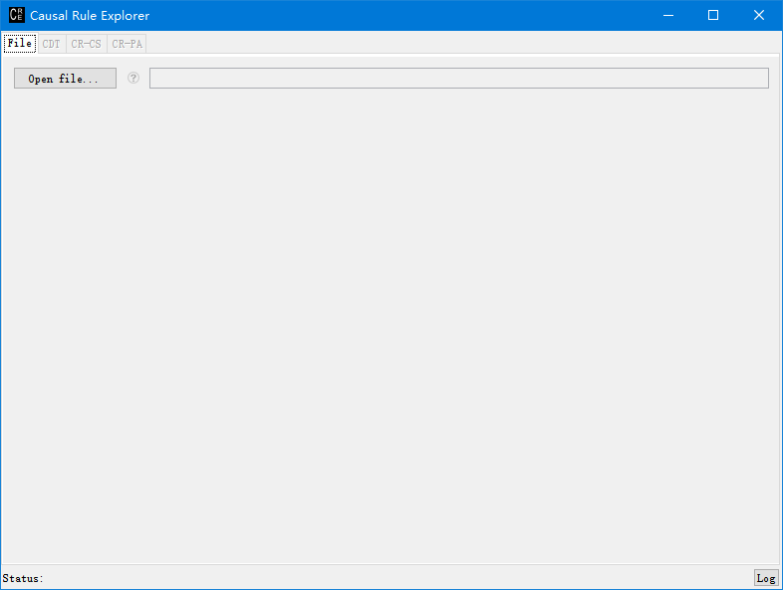

Figure 1

1. Open the input file. Double-click the “Open file...” button. Select the input file. Click the question mark on the right for help.
2. Select the algorithm on the right tab, e.g. CDT as Figure 2.

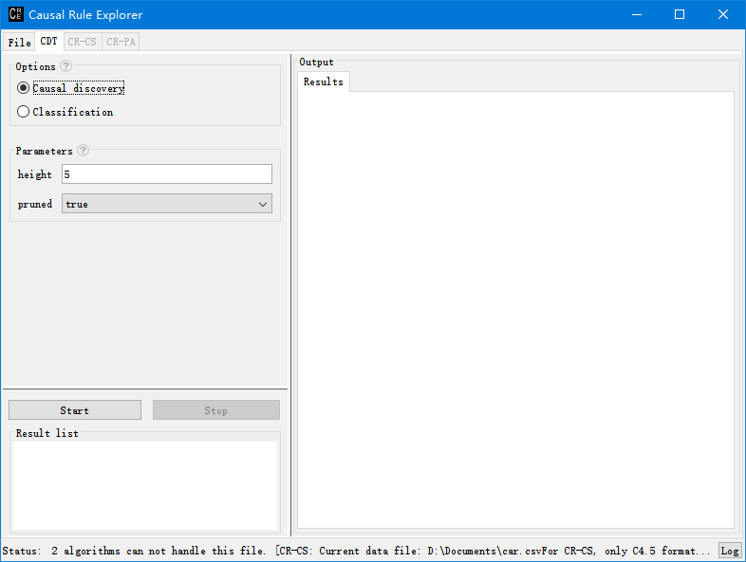

Figure 2

1. Configure the options and parameters on the left-top panel. Click question mark for help.
2. Click the “Start” button to run the algorithm.
3. Obtain the results. The results are shown on the right panel as Figure 3 and Figure 4.

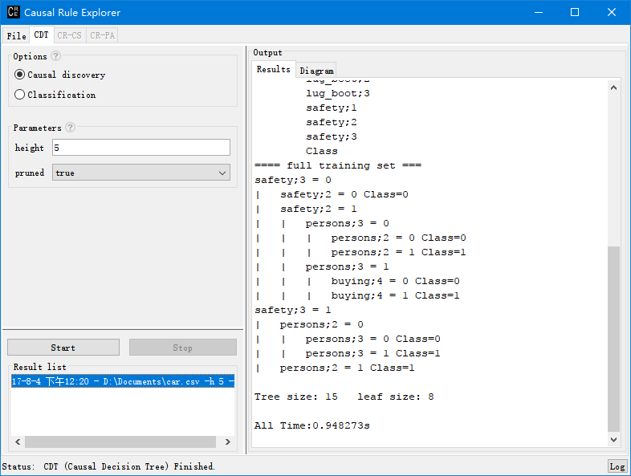

Figure 3

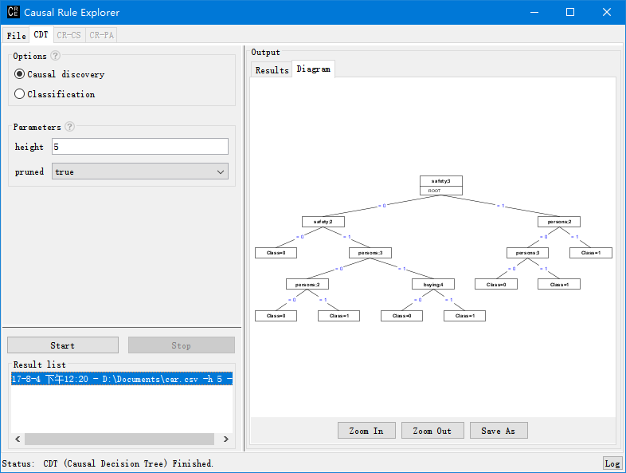

Figure 4

1. The history results are on the left-bottom panel. Click the item and results will show on the right panel.